Schedule coordination procedures at EURO 2020

Table of contents
Schedule coordination procedures during EURO 2020 1
Introduction 3
1. Affected airports by EURO 2020 procedures 3
2. Coordination of summer season 2020 during EURO 2020 6
1.1 Coordination period 6
1.2 General coordination principles 7
1.3 Slots requests 7
1.4 Requests of slots for flights specific for EURO 2020 8
1.4.1 Use of Specific Service Type Code (STC) 8
1.4.2 SI text (supplementary information) 8
1.5 Handling of requests for series of slots 8
1.6 Handling of requests for ad hoc slots 8
a. Handling of requests for ad hoc slots for group matches dates 9
b. Handling of requests for ad hoc slots for knock out phase 9
c. Priorities for slot allocation during EURO2020 9
3. Slot monitoring 10

Introduction
For the first time the European football championship EURO 2020 organized by UEFA will be played across 12 countries between June 12th and July 12^{th,} 2020.
Matches will be organized in the stadiums of the following cities: Rome, Baku, St Petersburg, Copenhagen, Amsterdam, Bucharest, London, Glasgow, Bilbao, Dublin, Munich, Budapest.
The objective of this procedure is to implement a set of rules and procedures applicable to the affected airports during EURO 2020 in order to:
- Maintain the usual traffic at the airport;
- Process the additional planned traffic specific to the tournament;
- Inform all aircraft operators about the specific rules applicable on the concerned airports and about the enforcement procedure.

Match schedule and airport affected airports by EURO 2020.
Airports impacted by the specific EURO2020 procedures
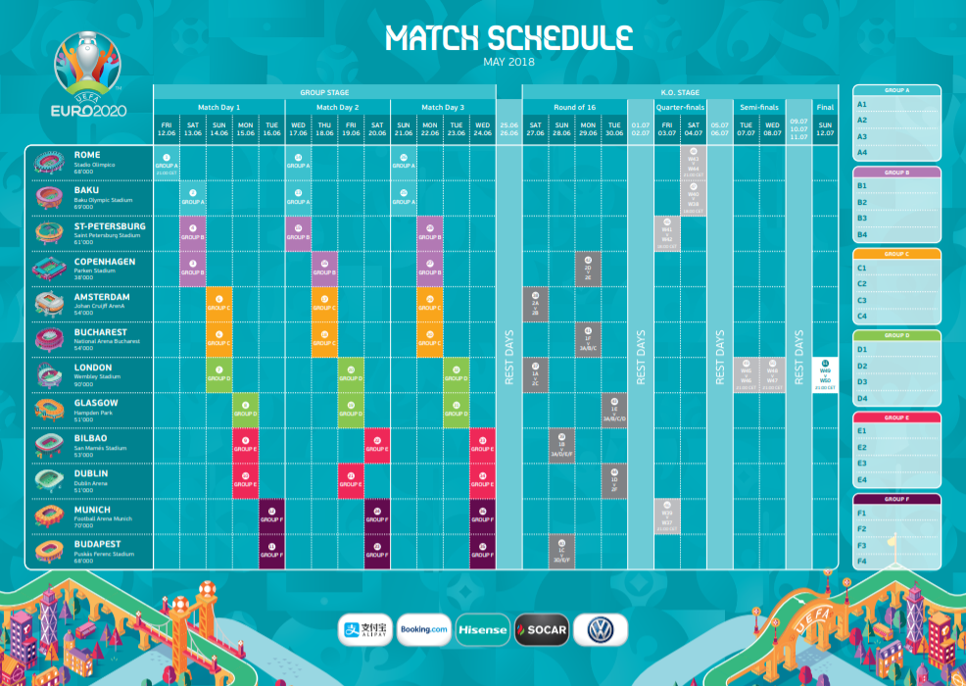

- Rome (FCO) & (CIA)
Coordinator: ASSOCLEARANCE (IT) email: slot@assoclearance.it telex: ROMSPXH
FCO is Level 3 H24 Out of office contact, email: csf@adr.it phone: +39 06 65955000 clearanceFCO@adr.it phone: +39 06 659580050 / + 39 06 659524779 / +39 06 659524726 / +39 06 659524794
CIA is Level 3 with night curfew 23:00 – 06:00 LT. Out of office contact, email: aptcoordinationcia@adr.it phone: +39 06 65959298

- St Petersburg (LED)
Coordinator : LED (RU) coordination@pulkovo-airport.com (website www.pulkovoairport.ru)
LED is Level 2 SMA and H24.

- Copenhagen (CPH)
Coordinator : CPH (DK) www.airportcoordination.com
CPH is a fully Coordinated Level 3 Airport. H24.
Valid from 11.June - 30.June 2020: Airport is affected: Two days before the match - on the day of the match and also on the day following the match.
Only ten movement related to UEFA CUP 2020 are permitted per hour and of course within the standard parameters/limitations
All aircraft must leave the airport as soon as possible after off-loading the passengers, including teams and VIPs and limit the staying time to minimum ground stop.
The maximum staying time (the gap between arrival and departure) is limited to 2 hours (unless the Danish police for security reasons decide otherwise on selected flights).
Agreement with a handling agent is a prerequisite for operating into CPH and the name of handling agent must be stated in the Schedule Clearance Request (SCR)
Alternativ Airports nearby: Roskilde / RKE / EKRK (45km), Malmo / MMX / ESMS (60km), Odense / ODE / EKOD (180km) Please refer to AIP/NOTAM for more information.
Out of hours contact is the Coordinator scr@airportcoordination.com if SSIM format or acd@airportcoordination.com if non SSIM.

- Amsterdam (AMS) (EIN) (RTM) :
Coordinator: ACNL (NL) scr@slotcoordination.nl (website www.slotcoordination.nl)
All three airports are Level 3 coordinated for Commercial aviation. Due to seasonal capacity limits at all Dutch level 3 coordinated airports it is expected there is no (additional) slot capacity available during the EURO 2020 event.
Night restrictions : AMS is open 24HRS, with a night regime. It is expected there are no (additional) night slots available during the EURO 2020 event .
EIN & RTM are closed during the night.
General aviation : AMS is not affected by the seasonal capacity limit and prohibited during the night regime (2040-0455 UTC DEP & 2100-0515 UTC ARR not allowed). Night slots can only be granted in exceptional circumstances (Local Rule). EIN is not coordinated by ACNL. For RTM a defined category of GA is coordinated by ACNL.
Lelystad airport (LEY) : the decision of opening the airport has been postponed until further notice.
More information about AMS/EHAM, EIN/EHEH & RTM/EHRD capacities can be found in the capacity declarations S20 at www.slotcoordination.nl

- London (STN) (LTN) (LGW) (LHR) (LCY)
Coordinator: ACL (UK) lonacxh@acl-uk.org (website www.acl-uk.org)
All five airports are Level 3.
(STN) very limited availability at night. Out of office contact, email: airfield_ops@stanstedairport.com , phone : +44 (0)1279 662 478.
(LTN) NO availability at night 2200-0559z, ban on additional night flights 01Jun-30Sep. Very limited overnight parking. Flights should operate during daytime hours and keep ground time to a minimum. Out of office contact, email: operations.control@ltn.aero , phone : +44 (0)1582 395525.
(LGW) very limited availability at night in adhoc pool, allocation at Gatwick Airport Ltd discretion. Out of office contact, email: flow.planners@gatwickairport.com , phone : +44 (0)1293 503 089 or 503221.
(LHR) no night movements available. Out of office contact, email: ocs@heathrow.com , phone : +44 (0)208 745 6033
(LCY) Closed Mon-Fri 2100-0529z and 1130z Sat to 1129z Sun. Very limited parking. Out of office contact, email: standplanner@londoncityairport.com , phone : +44 (0)207 646 0083.

- Glasgow (GLA) & (PIK)
Coordinator: ACL (UK) lonacxh@acl-uk.org (website www.acl-uk.org)
GLA is Level 2 SMA and H24. Out of office contact, email: GLADutyManagerTeam@glasgowairport.com , phone +44 (0)141 848 4510 / +44(0)7831 170676.
PIK is not coordinated, contact airport / handling agent.

- Bilbao (BIO)
Coordinator: AECFA (ES) slots@aecfa.es (website www.slotcoordination.es)
BIO is Level 3, not H24 (closure times between 21:30 and 04:45). Special permission for night operations during Euro 2020 not expected. Both Commercial Aviation and GA/BA always coordinated under the same airport capacity parameters. Early departures and late arrivals extremely hard to get on weekdays. Out of office contact: email: bio.gtr@aena.es Phone: +34 944869658 CECOPS (APOC)

- Dublin (DUB)
Coordinator: ACL (UK/Ireland) slots@acl-international.com (website www.acl-uk.org)
DUB is Level 3 and is H24. Very limited overnight parking,. Out of office contact, phone: +353 1 8145228

- Munich (MUC)
Coordinator : Fluko (DE) fraztxh@fhkd.org (website www.fhkd.org)
MUC is Level 3, night restriction 2330-0500 LT, limited availability between 2200-2330 + 0500-0600 LT.

- Budapest (BUD)
Level 2, night restriction 2200-0555 LT
Coordinator : Hungarocontrol – budcoord@hungarocontrol.hu
Website : https://en.hungarocontrol.hu/about-us/airport-coordination

- Baku (GYD)
No details provided.

Airports that are opened during the night may be subject to environmental restrictions. Please refer to AIP/NOTAM for more information.

Airports are affected on the day of the match and also on the day following the match.

In this procedure, some specific paragraphs are indicated as relevant only if the airport is affected.
Those specific paragraphs (paragraph 2) will be applicable for flights:
- which are operating on an affected date (arrival and/or departure);
- for which the aircraft is intended to stay on the airport over one of the affected date.

The table below shows which airports are affected at which date:
Date | FCO/CIA | GYD | LED | CPH | AMS | OTP | London | GLA/PIK | BIO | DUB | MUC | BUD
12/06/2020 | x |  |  |  |  |  |  |  |  |  |  |  | Group Matches
13/06/2020 | x | x | x | x
14/06/2020 |  | x | x | x | x | x | x
15/06/2020 |  |  |  |  | x | x | x | x | x | x
16/06/2020 |  |  |  |  |  |  |  | x | x | x | x | x
17/06/2020 | x | x | x |  |  |  |  |  |  |  | x | x
18/06/2020 | x | x | x | x | x | x
19/06/2020 |  |  |  | x | x | x | x | x |  | x
20/06/2020 |  |  |  |  |  |  | x | x | x | x | x | x
21/06/2020 | x | x |  |  |  |  |  |  | x |  | x | x
22/06/2020 | x | x | x | x | x | x
23/06/2020 |  |  | x | x | x | x | x | x
24/06/2020 |  |  |  |  |  |  | x | x | x | x | x | x
25/06/2020 |  |  |  |  |  |  |  |  | x | x | x | x
26/06/2020
27/06/2020 |  |  |  |  | x |  | x |  |  |  |  |  | Knock-out phase
28/06/2020 |  |  |  |  | x |  | x |  | x |  |  | x
29/06/2020 |  |  |  | x |  | x |  |  | x |  |  | x
30/06/2020 |  |  |  | x |  | x |  | x |  | x
01/07/2020 |  |  |  |  |  |  |  | x |  | x
02/07/2020
03/07/2020 |  |  | x |  |  |  |  |  |  |  | x
04/07/2020 | x | x | x |  |  |  |  |  |  |  | x
05/07/2020 | x | x
06/07/2020
07/07/2020 |  |  |  |  |  |  | x
08/07/2020 |  |  |  |  |  |  | x
09/07/2020 |  |  |  |  |  |  | x
10/07/2020
11/07/2020
12/07/2020 |  |  |  |  |  |  | x
13/07/2020 |  |  |  |  |  |  | x
Table 1 – Affected airports per date

Coordination of summer season 2020 during EURO 2020

2.1 Coordination period
All airports are coordinated at their normal status level. No temporary increased level status is planned.

General coordination principles
- All flights, regardless of the category (scheduled, non-scheduled, Business or General Aviation) departing from or arriving to any of the coordinated airport during EURO2020, will require an airport slot allocated by the coordinator prior to the operation and prior to filing the corresponding ATC flight plan.
The following flights are exempted from slot allocation but we highly recommend that the operators keep us informed of their intention even at short notice:
- Medical, emergencies, evacuation or humanitarian flights;
- State and military flights;
- Search and rescue operations;
- Emergency operations.

Slots requests
Slots requests should be made in SSIM format (SMA/SCR) to the relevant coordinator.
- Slots for general and business aviation flights shall be requested by operators via their ground-handling agent.
Slots requests must be submitted in turnaround format (except flights using existing aircraft based at that airport). Not required for the Netherlands , but can be accepted.

Requests of slots for flights specific for EURO 2020

Use of Specific Service Type Code (STC)
In order to identify requests specific for the EURO2020 among all other requests, operators are required to use the specific following service type codes for these flights:
- use of service type code “O” for any flight with passengers;
- use of service type code “P” for any positioning flight;
- use of any combination O-O, O-P, P-O For the turnaround format.
Service type code “O” shall be used only for flights specific for the EURO2020.

SI text (Supplementary Information)
SI text on slot requests should contain the following information.
- EURO2020 FANS – (ie. EURO2020 FANS SPAIN)
- EURO2020 TEAM (ie. EURO2020 TEAM ENGLAND)
- EURO2020 REFEREE (ie. EURO2020 REFEREE FOR SPAIN VS ENGLAND MATCH)
As teams/fans may be travelling from a previous match or future match it may not be obvious without this information as to which country they are from.
The list of flights carrying teams / referees may be crosschecked with UEFA.

Handling of requests for series of slots
Requests for series of slots will be processed as usual by the coordinator. A close monitoring of the use of slots allocated as part of a series which covers the period of the EURO2020 will be made by the coordinator. Strict enforcement of EU95/93 article 14.6 will be made in order to cancel the remainder of the slots from a series which is not being used.

Handling of requests for ad hoc slots
All ad hoc flights that intend to operate on an airport at a date concerned by a match will be held on the waiting list. The waiting list will be processed following the rules below.

Handling of requests for ad hoc slots for group matches dates
- Once the draw is made on 30 November 2019 adhoc slots for flights for the group stages may not be requested but may not be confirmed until after 01 February 2020. (Some coordinators allocate adhocs prior to 01Feb).

Handling of requests for ad hoc slots for knock out phase
- Ad hoc slot requests will be held on the waiting list and will be processed latest 2 days before the match for the knock-out rounds. Slots will not be allocated for speculative requests and requests should only be made once teams are known.

Priorities for slot allocation during EURO2020
- Requests for slots will be processed in accordance with the WSG and EU Slot Regulations.

Slot monitoring
- Normal Slot Monitoring will take place during Euro 2020 with actual times measured against their slot time. Slot Sanctions may apply in cases of abuse.

